Gypsy Card Readings with Catherine Ann Jones
"Catherine showed me how to find my way out of the darkness and into the light."
45 years experience as a psychic reader with clients both here and abroad.
The readings cover recent past, current, and up to a year in the future.
For appointments in Palm Springs, Sat or Sun, June 4-5, call 805 223-0002
($125 for 45 minutes or $250 for 1.5 hours)
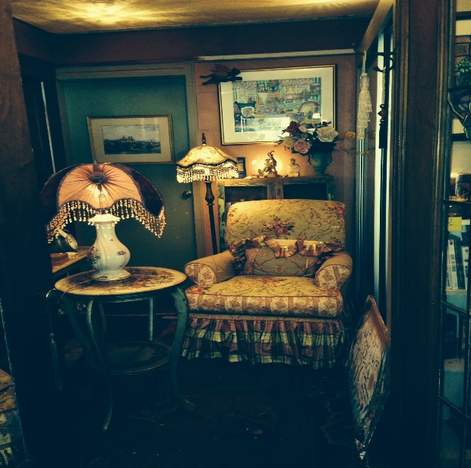
"You are a world-class wisdom keeper for our times."
“Thank you for the guidance you gave me yesterday.
My hope has been renewed by knowing where to focus."

